Number Game - Number Group bet type
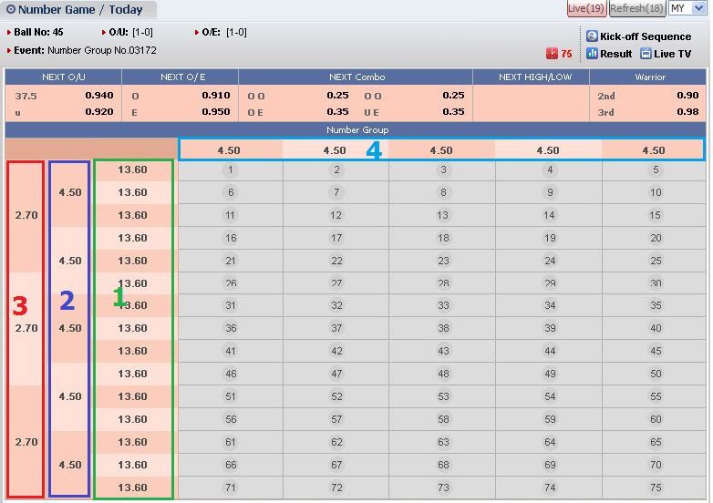
1,2,3,4 are Group ID which is stored in bettrans.hdp1
- Total Bets:
- Add one more column Number Group, it sums up all tickets belong to Number group bet-type
- Bet list
Display the same with other bet-types
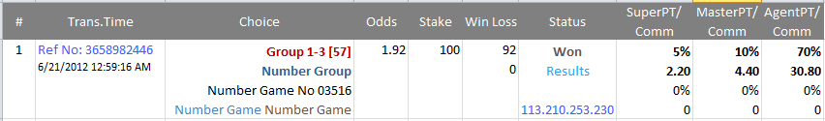
The difference:
- Choice: Group 1-3 [Live score]
  - 1: the number ID of group, stored in Bettrans.Hdp1.
  - 3: the position of selection, stored in Bettrans.Betteam
- Do not show odds type name in Odds column since this bet-type is applied Decimal odds
Bet Slip
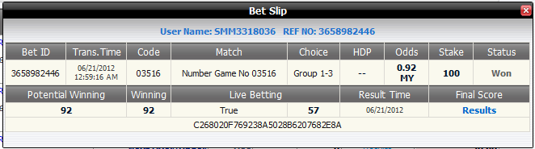
- Accounting site
  - Settlement
  - Report 2h details Live and None Live sections
  - Special delete, Ticket listing, Reports: verify again.
- PT Setting
  - Verify update function
  - Confirm the setting at the first launch.
- Announcement about the launching

